Vuk Tapušković
Academy Director/Head Coach
Tennis Center Serbia
mobile: +381-64-1707-881
email: vuktapuskovic@gmail.com

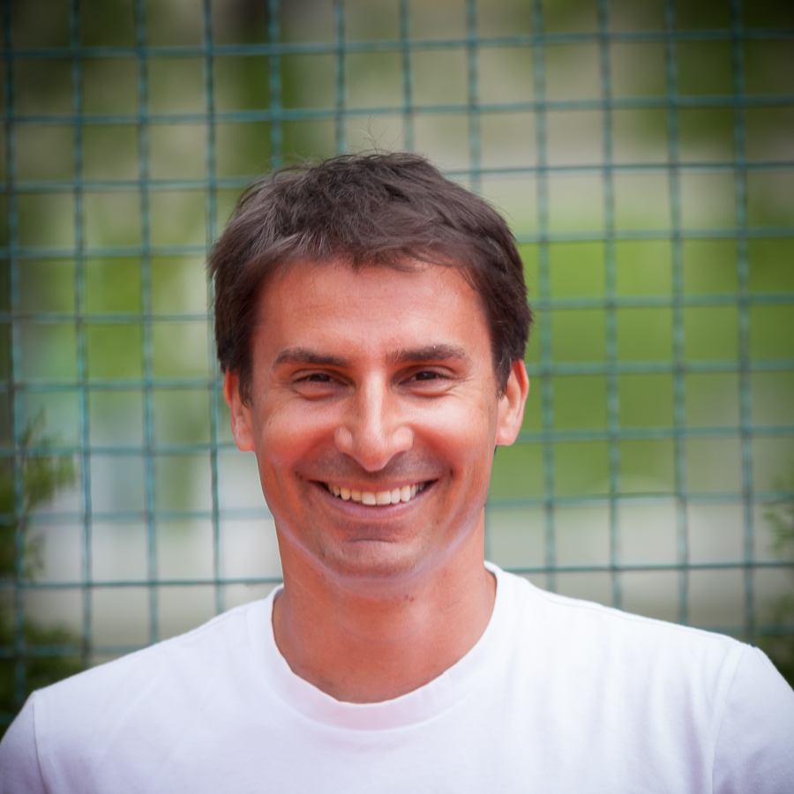

SUMMARY OF QUALIFICATIONS

- 27 Years of Teaching Tennis Professionally
- Have Extensive Experience in:
- Teaching all Ages and Abilities
- Fully Running a Tennis Program at a Country Club/Tennis Academy as a Tennis Director (10 years)
- Being in Charge of a Tennis Staff and a Tennis Pro Shop
- Organizing and Running all Tennis Related Events
- Running and Overseeing Complete Adult and Junior Program
- Running Team Practices and Matches for all Levels of Adult and Junior Teams
- Teaching Tennis Related Seminars
- Consulting Tennis Clubs and Academies
- Working full time with Professional Tennis Players
- Ability to Motivate and Create a Great Deal of Enthusiasm Amongst Students and Staff
- Excellent Organizational and People Skills
- Speak 2 Languages: English, Serbian
- B Coaching License – Serbian Tennis Federation (Europe highest level)

PROFESSIONAL EXPERIENCE

2016-present Tennis Director, Weston Field Club, Weston, CT
2017 Personal Coach of Serbian Fed Cup team member Ivana Jorovic (WTA high rank #130)
2016 Personal Coach of Serbian Fed Cup team member Nina Stojanovic (WTA high rank #124)
2016 Assistant Director, Beach Point Club, Mamaroneck, NY
2015- 2016 Personal Coach of Serbian Fed Cup team member Doroteja Eric (WTA high rank #218)
2013-2015 Personal Coach of number 1 junior in the world Ivana Jorovic (coached Ivana to a 90-19 record on ITF and WTA tour during that time, took her from ITF rank #250 to ITF rank #1, finals of junior French Open, finals of 18’s Orange Bowl, won WTA 50K at the age of 17)
2013-present Academy Director/Head Coach/Co-Founder, Tennis Institute of Belgrade, Belgrade, Serbia www.tennisinstituteofbelgrade.com
2012-present Head of the Experts Committee of the Belgrade Tennis Federation
2012-2013 Tennis Director, Topaco Country Club, Belgrade, Serbia www.tktopaco.com
2008-2012 General Manager/Tennis Director, Green Set Country Club, Belgrade, Serbia www.tkgreenset.com
2008-present Have sent over 30 top ranked juniors to American Universities on tennis scholarships
2008-2011 National Junior Coach/Program Coordinator for Serbian Tennis Federation
2007-2008 Tennis Director, Lokomotiva summer national junior tennis camps, Belgrade
2007-2008 Personal coach of an ATP Tour Player Nikola Cacic (ATP tour high singles rank #281, high doubles rank #240)
2005-2008 Tennis Director/Head Coach, Red Star Tennis Academy, Belgrade, Serbia
As a Head Coach at the “Red Star” won 2 Serbia’s Men’s National Team Championships, 1 Women’s National Team Championship and 3 Junior National Team Championships. During the course of these 3 years worked with such players as:
- Jelena Jankovic (WTA tour high rank #1)
- Viktor Troicki (ATP tour high rank #12)
- Boris Pashanski (ATP tour high rank #55)
- Katarina Misic (WTA tour high rank #220)
- Ana Timotic (WTA tour high rank #199)
- Nikola Ciric (ATP tour high rank #151)

2001-2005 Head Pro, Weston Field Club, Weston, CT
2002-2004 Personal coach of an ATP Tour Player Jan Frode Andersen
(ATP tour high rank #130)
  - Head Assistant, Kings Highway Tennis Club, Darien, CT

Head Assistant - Junior Director, Simsbury Tennis House and Canton Racquet Club, Simsbury and Canton, CT (sister clubs)
1995-1997 Assistant Pro, Bollettieri Tennis Academy, FL and CT
  - Assistant Pro, Jewish Community Center, Tucson, AZ
  - Assistant Pro, Tucson Country Club, Tucson, AZ

Assistant Pro, Tucson Racquet Club, Tucson, AZ
1991-1992 Assistant Pro, Canton Racquet Club, Canton, CT

PLAYING EXPERIENCE

- Ranked top 10 in all junior age groups in Yugoslavia (all ex-republics)
- Serbian National Champion in 18 and under category
- Two-time Yugoslavian National Junior Team Champion with “Red Star” tennis club
- One-time Serbian National Men’s Team Champion with “Red Star” tennis club
- Number 1 Doubles and Number 5 Singles, 3 Years, University of Arizona, Tucson, AZ
- Held an ATP doubles ranking for 3 years

EDUCATION
1992-1997 Degree in Computer Engineering University of Arizona, Tucson, AZ
1991-1992 Southington High School Southington, CT
1988-1991 14th Belgrade Gymnasium Belgrade, Serbia

